Exploring the Cosmos: A Journey through the Solar System

# Introduction

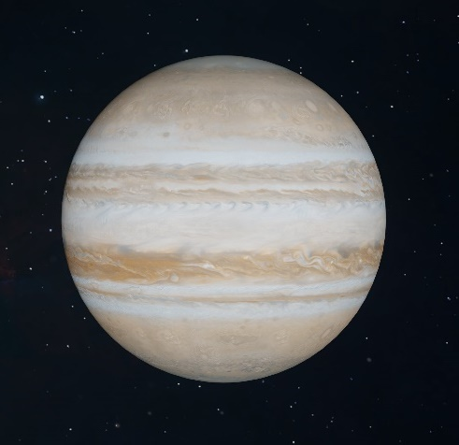The solar system, a cosmic marvel that has captured human imagination for centuries, is a vast expanse of celestial bodies orbiting the life-giving star we call the Sun. Let's embark on a cosmic journey as we delve into the wonders of our solar neighborhood.

# The Sun - Our Radiant Center

At the heart of it all, the Sun reigns as the gravitational maestro, orchestrating the dance of planets, moons, and asteroids. Discover the Sun's role in providing light, heat, and the essential energy for life on Earth.

# The Sun's Composition

Unravel the secrets of the Sun's composition – a blazing ball of hydrogen and helium, where nuclear fusion transforms matter into energy, creating the radiant glow that sustains our solar system.

# The Inner Planets

## Mercury, Venus, Earth, and Mars

Venture into the inner realms of our cosmic neighborhood, where the rocky planets play a vital role in shaping the dynamics of the solar system. From the scorching plains of Mercury to the red deserts of Mars, each planet has a unique tale to tell.

# Earth - Our Blue Oasis

Dive into the diverse landscapes of Earth, the only known celestial body to support life. Explore the intricacies of our home planet's atmosphere, geology, and the delicate balance that sustains the rich tapestry of life.

# The Asteroid Belt - Celestial Debris in Orbit

Navigate through the asteroid belt, a cosmic highway of rocky remnants, situated between Mars and Jupiter. Uncover the mysteries of these celestial fragments and their impact on the formation and evolution of our solar system.

# The Outer Giants

## Jupiter, Saturn, Uranus, and Neptune

Enter the majestic realm of the gas giants, where colossal planets with swirling storms and mesmerizing rings dominate the outer reaches of our cosmic neighborhood. Explore the unique characteristics of each giant, from Jupiter's colossal storms to Neptune's icy winds.

## Saturn's Rings

### A Cosmic Symphony

Marvel at the breathtaking beauty of Saturn's rings, a celestial spectacle that has fascinated astronomers for centuries. Discover the composition of these rings and the ongoing mysteries surrounding their origin.

# Dwarf Planets and Beyond

Embark on a journey beyond the traditional planets as we explore the dwarf planets and other intriguing celestial bodies that lurk in the farthest corners of the solar system. From Pluto, once considered the ninth planet, to the icy Kuiper Belt, the outer limits hold secrets yet to be fully unveiled.

# New Horizons and Beyond

Celebrate the achievements of space exploration missions like New Horizons, which provided unprecedented insights into Pluto and the distant Kuiper Belt. Learn about ongoing efforts to probe the farthest reaches of our cosmic backyard.

# Conclusion

As we conclude our cosmic odyssey through the solar system, we're left in awe of the intricate dance of planets, moons, and asteroids that make up our celestial neighborhood. The solar system, a testament to the wonders of the cosmos, continues to inspire scientists, astronomers, and dreamers alike.

